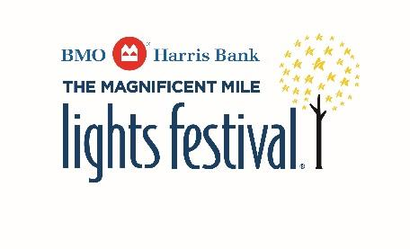

STREET CLOSURES and START TIME for

The BMO Harris Bank Magnificent Mile Lights Festival®

Saturday, November 20, 2021

The Magnificent Mile® Association will celebrate The BMO Harris Bank Magnificent Mile Lights Festival® this year on Saturday, November 20, 2021. As one of the Association’s most magical and popular events, it is anticipated that the Lights Festival will draw a significant amount of guests to the area for this single day event.

To successfully execute all planned activities, we anticipate the following street closures:

MAIN STREET CLOSURES: Closed 3:30 p.m. – 7:30 p.m. on Saturday, November 20
- Oak Street (State Street to Michigan Avenue)
- North Michigan Avenue (Oak Street to Wacker Drive)
- Upper Wacker Drive (Michigan Avenue to east turnaround)

Closed 5:00 p.m. – 7:30 p.m. on Saturday, November 20
- Upper Columbus (Wacker Drive to Randolph)

ADDITIONAL STREET CLOSURES: Closed 8 a.m. – 6 p.m. on Saturday, November 20
- Clark Street (East curb lane only Oak Street to Delaware Street)
- Delaware Street (Dearborn Street to Clark Street north curb lane only)
- Oak Street (Clark Street to State Street)
- Dearborn Street (Delaware Street to Maple Street)
- Walton Street (State Street to Clark Street)

Closed 3:30 p.m. – 9 p.m. on Saturday, November 20
- Upper Columbus (Curb lanes from Wacker Drive to Randolph Street)
- Randolph Street (Curb lanes from Michigan to Columbus)

*Please note that Lights Festival Lane, at 401 N. Michigan, will run from 11 am - 4 pm and the lighting procession will step-off this year at 5:30 p.m. from Oak Street & North Michigan Avenue.*

Please mark your calendar and share this valuable information so that appropriate planning and accommodations may be made in advance. If you have any questions or concerns, please contact The Magnificent Mile® Association at (312) 642-3570.

